PHYS 202 Practice for final
Coulomb’s law 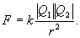 Coulomb’s constant = k = 9 x 10⁹ (SI)
1. In the Bohr model of the hydrogen atom, the electron is in a circular orbit about the nuclear proton at a radius of 5.29 x 10⁻¹¹ m as shown below. The mass of the electron is 9.11 x 10⁻³¹ kg. Determine the speed of the electron. [Centripetal Force = $F_{C}=\frac{mv^{2}}{r}$]
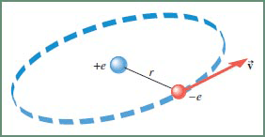

Ohm’s Law V = IR
2a. What is the direction of current for the circuit shown?
a. Clockwise b. Counter clockwise
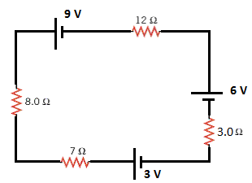
2b. Determine the magnitude of the current for the circuit shown?
a. 0.38 A b. 0.40A c. 0.50 A d. 0.60 A e. 0.20 A
2c. What is the voltage across the 12 ohm resistor?

Capacitance = C = Q/V
3. What is the charge in the 3 µF capacitor for the circuit shown below?
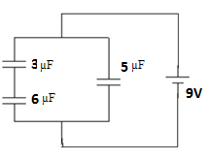

III. Combine all the resistances into a single one, between A & B, for the circuit shown:
b. What is the voltage across the 4Ω resistor when a 6-v battery is connected between A and B.
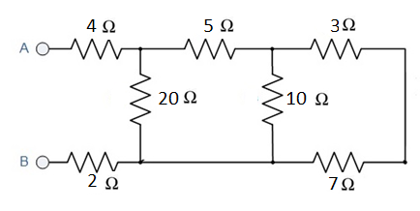

Ampere’s Law
IV. The magnetic field due to a long straight wire, carrying a current I, at a distance r is given by;
(μ₀= 4πx10⁻⁷ T.m/A)
$B=\frac{μ_{0}I}{2πr}$
a. Show the magnetic field, circling the long-wire carrying current I (out of page and into page) using circles with directions, above.
b. In the figure below, two long straight wires are perpendicular to the page and separated by distance d₁ = 0.75 cm. Wire 1 carries 6.5 A into the page and wire 2 carries 4.5 A out of the page. What are the (a) magnitude and (b) direction of the net magnetic field due to the two currents at point P? (d₂ = 1.50 cm from wire 2)

